FOR IMMEDIATE RELEASE

Michael Oswald Caplan
September 20, 1931 – September 6, 2016

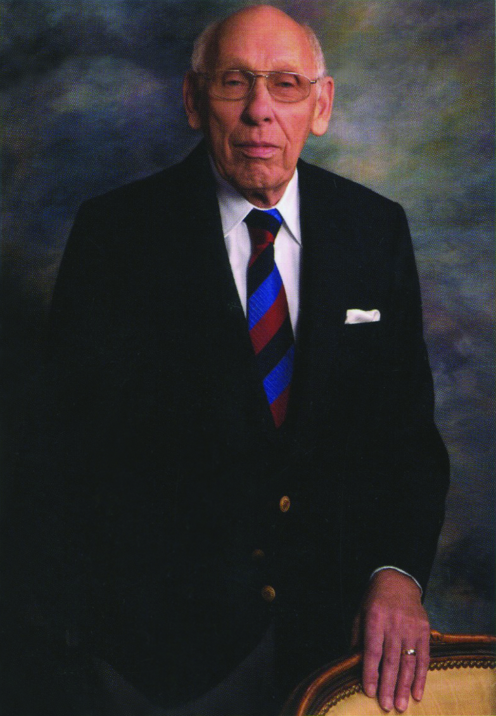
Delta, BC, September 7, 2016 – It is with great sadness that we announce the passing of Task Tools’ founder, Michael Caplan, shortly after 9 pm on September 6th, 2016. He will be deeply missed by his wife Bearl; son Craig (Jennifer); daughter Hilary (Scott); grandchildren Braeden, Sienna, Mikyla, and Annika; sisters Corinne and Valerie (Jake); stepsister Jane; and many other nieces, nephews and extended family members. Michael was predeceased by his younger brother, Perry.

Michael Oswald Caplan was born in Hull, England on September 20, 1931. In 1955 he immigrated to Canada and worked for 3 years on the Distant Early Warning radar system that was being built across the country. He was a dispatcher, radio operator, and commercially licensed pilot, based in Yellowknife and Cambridge Bay, North West Territories.

In 1962 Michael married his wife, Bearl, and they moved back to England so Michael could take a senior management position he’d been offered. Son Craig and daughter Hilary were born in England (1963, 1967). After 5 years Michael and Bearl longed to be back in Canada so with two children in tow they headed back.

In 1968, Michael bought a small company from his wife’s father who wanted to retire. That company was known as East West Distributors and with one product (the Uni-Disc™ multipurpose sanding disc), the family station wagon, and a strong desire to succeed, Michael set out on a mission to grow his company across the country. From these humble beginnings, Task Tools, a true Canadian success story, was born.

While building the company he also made time for community contributions. For 20 years, Michael was a very active member of the Kiwanis Club, an organization dedicated to community service. While serving as President of the local chapter, he was instrumental in the club initiative to bring Crime Stoppers to Vancouver in the late 80’s.

As the company grew, Michael brought his son, Craig (now Chairman & CEO), and son-in-law Scott Doré (now President), into the business.

In 2007, at the age of 76 while still working fulltime, Michael was inducted into the Canadian Hardware & Housewares Manufacturers Association (CHHMA) Industry Hall of Fame.

Michael retired as Chairman of Task Tools in 2008.

Michael enjoyed music and learned to play clarinet and saxophone in his youth. He played in several jazz and swing bands as a young man and continued playing into his senior years with bands in Vancouver (Metro Big Band) and Arizona (New Horizons Band), where he and his wife spent their winters.

Michael Caplan was a good, honorable, hardworking man who inspired those around him to do their very best at work and in life. His legacy lives on in the building supply, hardware and industrial supply industries across North America and we at Task Tools honor his legacy each and every day through dedicated service to our customers.

About Task Tools
Founded in 1968, Task Tools is a Canadian, family owned and operated business that provides quality products, exceptional customer service, award-winning packaging & merchandising, and the industry’s best warranty support to the building supply, hardware and industrial supply industries throughout North America.

Task Tools offers three brands – Task Signature®, Task® and Tuf-E-Nuf® – which sell in six categories: power tool accessories, hand tools, abrasives, worksite accessories, cargo accessories, and innovative electrical accessories.

For more information, go to www.task-tools.com.

Trade Proven. TASK® Tough.™

